Scope

This document applies to Automated Teller Machine software

ATM version1.0.

This software facilitates the user to perform various transactions in his account without going to bank. This software offers benefits such cash withdrawals, balance transfers, deposits, inquiries, credit card advances and other banking related operations for customers.

It also allows the administrator to fix the tariffs and rules as and when required. The software takes as input the login Id and the bank account number of the user for login purposes. The outputs then comprise of an interactive display that lets the user select the desirable function that they want to perform.

* Initial Requirements
  + User Stories
    - **As a user, I would like to _____ so that I can ______**
  + Use cases
    - More formal, user/system interaction

User Characteristics

There are different kinds of users that will be interacting with the system. The intended users of the software are as follows:

Customer A:

A novice ATM customer. This user has little or no experience

with electronic means of account management and is not a frequent user

of the product. User A will find the product easy to use due to simple

explanatory screens for each ATM function. He is also assisted by an

interactive teaching mechanism at every step of the transaction, both with the help of visual and audio help sessions.

Customer B:

An experienced customer. This user has used an ATM on several

occasions before and does most of his account management through the ATM. There is only a little help session that too at the beginning of the session thus making the transaction procedure more faster.

Operator:

A bank employee. This user is familiar with the functioning of the ATM. This user is in charge of storing cash into the ATM vault and repairing the ATM in case of malfunction. This user is presented with a different display when he logs in with the administrator’s password and is provided with options different from that of normal user.

He has the authority to change or restrict various features provided by the software in situations of repairing.

Bank:

A financial institution that transactions must interface and clear(validate) through.

Product Functions

The major functions that ATM performs are described as follows:

Language Selection: After the user has logged in, the display provides

him with a list of languages from which he can select any one in order to

interact with the machine throughout that session. After the language

selection the user is prompted with an option that whether he wants the

selected language to be fixed for future use so that he is not offered with

the language selection menu in future thus making the transaction a bit

faster. User also has the freedom to switch to a different language

mentioned in the list in between that session.

Account Maintenance:The various functions that a user can perform

with his account are as follows:

* Account Type: The user has the freedom to select his account type to which all the transactions are made, i.e. he can select whether the account is current account or savings account etc.
* Withdrawal/Deposit: The software allows the user to select the kind of operation to be performed i.e. whether he wants to withdraw or deposit the money.
* Amount: The amount to be withdrawn or deposited is then mentioned by the user.
* Denominations: The user is also provided with the facility to mention the required denominations. Once he enters his requirements the machine goes through its calculations on the basis of current resources to check whether it is possible or not. If yes, the amount is given to the user otherwise other possible alternatives are displayed.
* Money Deposition: Money deposition shall be done with an envelope. After typing the amount to be deposited and verification of the same, the customer must insert the envelope in the depositary.
* Balance Transfer: Balance transfer shall be facilitated between any two accounts linked to the card for example saving and checking account.
* Balance Enquiry: Balance enquiry for any account linked to the card shall be facilitated.

Billing: Any transaction shall be recorded in the form of a receipt and the

same would be dispensed to the customer. The billing procedures are

handled by the billing module that enable user to choose whether he wants

the printed statement of the transaction or just the updation in his account.

Cancelling: The customer shall abort a transaction with the press of a

Cancel key. For example on entering a wrong depositing amount. In

addition the user can also cancel the entire session by pressing the abort

key and can start a fresh session all over again.

Map locating other machines: The machine also has a facility of displaying the map that marks the locations of other ATM machines of the same bank in the entire city.

Mobile Bills Clearings: The machine also allows the user to clear off his

pending mobile bills there only, if the name of his operator is mentioned

there in the list. The machine displays the list of the companies supported

by that bank to the user

USE CASE Diagram -

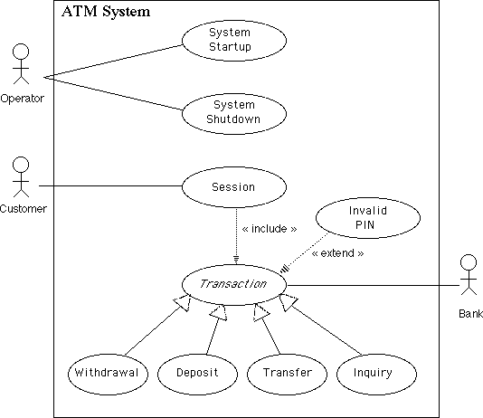

https://creately.com/blog/diagrams/use-case-diagram-tutorial/